Experiment No. 07
Name : Iqra Shaikh
Roll No.: 24DCO06
Batch: 01

Aim : Implementation of DVR in ns2 simulator.

Theory :
NS2 (Network Simulator 2):
- NS2 is an open-source, object-oriented, discrete event-driven simulator, licensed under GNU GPL v2.
- Written in C++ (for protocol implementation) and OTcl (for simulation setup and control).
- Mainly used for simulating wired and wireless networks (MANETs, VANETs, satellite, etc.).
NAM (Network Animator):
- NAM is a visualization tool used with NS2 that provides a graphical display of network simulations, showing nodes, links, and traffic activity in real time.
- It illustrates the movement of packets across the network, including events like generation,
- NAM is also valuable for debugging simulation scripts and presenting results visually, making complex network behavior easier to explain.
Installing ns2:
Sudo apt-get install ns2

Installing nam:
Sudo apt-get install nam

Program :

#Create a simulator object
set ns [new Simulator]
#Define different colors for data flows (for NAM)
$ns color 1 Blue
$ns color 2 Red
#Open the NAM trace file
set nf [open out.nam w]
$ns namtrace-all $nf
#Define a &#39;finish&#39; procedure
proc finish {} {
global ns nf
$ns flush-trace
#Close the NAM trace file
close $nf
#Execute NAM on the trace file
exec nam out.nam &amp;
exit 0
}
#Create four nodes
set n0 [$ns node]
set n1 [$ns node]
set n2 [$ns node]
set n3 [$ns node]
#Create links between the nodes
$ns duplex-link $n0 $n2 2Mb 10ms DropTail
$ns duplex-link $n1 $n2 2Mb 10ms DropTail
$ns duplex-link $n2 $n3 1.7Mb 20ms DropTail

#Set Queue Size of link (n2-n3) to 10
$ns queue-limit $n2 $n3 10
#Give node position (for NAM)
$ns duplex-link-op $n0 $n2 orient right-down
$ns duplex-link-op $n1 $n2 orient right-up
$ns duplex-link-op $n2 $n3 orient right
#Monitor the queue for link (n2-n3). (for NAM)
$ns duplex-link-op $n2 $n3 queuePos 0.5

#Setup a TCP connection
set tcp [new Agent/TCP]
$tcp set class_ 2
$ns attach-agent $n0 $tcp
set sink [new Agent/TCPSink]
$ns attach-agent $n3 $sink
$ns connect $tcp $sink
$tcp set fid_ 1
#Setup a FTP over TCP connection
set ftp [new Application/FTP]
$ftp attach-agent $tcp
$ftp set type_ FTP

#Setup a UDP connection
set udp [new Agent/UDP]
$ns attach-agent $n1 $udp
set null [new Agent/Null]
$ns attach-agent $n3 $null
$ns connect $udp $null
$udp set fid_ 2
#Setup a CBR over UDP connection
set cbr [new Application/Traffic/CBR]
$cbr attach-agent $udp
$cbr set type_ CBR
$cbr set packet_size_ 1000

$cbr set rate_ 1mb
$cbr set random_ false

#Schedule events for the CBR and FTP agents
$ns at 0.1 &quot;$cbr start&quot;
$ns at 1.0 &quot;$ftp start&quot;
$ns at 4.0 &quot;$ftp stop&quot;
$ns at 4.5 &quot;$cbr stop&quot;
#Detach tcp and sink agents (not really necessary)
$ns at 4.5 &quot;$ns detach-agent $n0 $tcp ; $ns detach-agent $n3 $sink&quot;
#Call the finish procedure after 5 seconds of simulation time
$ns at 5.0 &quot;finish&quot;
#Print CBR packet size and interval
puts &quot;CBR packet size = [$cbr set packet_size_]&quot;
puts &quot;CBR interval = [$cbr set interval_]&quot;
#Run the simulation
$ns run

Output :

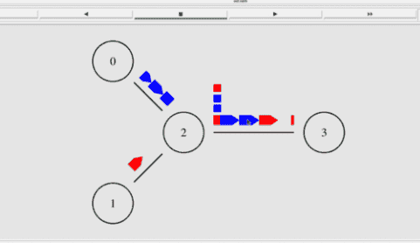
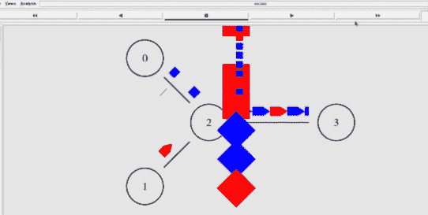

Explanation:

1. Node 1 (UDP source) starts first, sending packets continuously without ACKs.
2. UDP packets flow along the path toward the destination, filling the link bandwidth.
3. Node 0 (TCP source) starts later, sending its first packets.
4. TCP packets also enter the same outgoing queue shared with UDP packets.

5. Both flows compete for the same link capacity → queue builds up.
6. Since UDP never slows down, congestion forms at the router/queue.
7. Packets begin to get dropped when the queue overflows.
8. For TCP, dropped packets mean missing ACKs → TCP detects loss.
9. TCP reduces its sending rate (congestion control), while UDP continues at full rate.
10. Finally, you see packet loss and congestion in NAM, mostly affecting TCP, while UDP
keeps sending blindly.

Conclusion:

I understood the concept of DVR with TCP and UDP traffic and successfully implemented it in
NS2. The simulation clearly showed congestion, packet loss, and the difference in behavior
between TCP and UDP flows. This helped me practically verify the working of routing and
congestion control mechanisms.

